**IT24610817**

**Gunasena B.R.S.**

**IT2120 - Probability and Statistics – Lab Sheet 06**

**Exercise**

1. i)

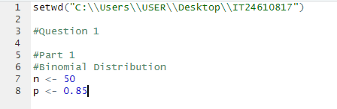





ii)



1. A close-up of a sign

   Description automatically generated i)

ii)

iii)